### **IT6203 Group Project - Milestone 3 Report**

**Group 5**

**Members:**

**Saketh Tatipally, Nikhilesh Buddi, Pavan Sai Kumar Jalluri, Navya Prakash Mamidisetti.**

**Project Title: Disaster Response and Relief App**

|  |  |  |  |  |  |
| --- | --- | --- | --- | --- | --- |
| **Component** | **Assigned Team Member** | **Create (C)** | **Read (R)** | **Update (U)** | **Delete (D)** |
| Component 1: Disaster Alerts | Saketh Tatipally | Generate real-time alerts using Weather API | View disaster alerts by location | Update disaster alerts in real-time | Remove alerts when resolved |
| Component 2: Donation Campaigns | Navya Prakash Mamidisetti | Create donation campaigns | View donation campaigns and opportunities | Update donation campaign progress | Close campaigns when completed. |
| Component 3: Help Requests & Volunteers | Pavan Sai Kumar Jalluri | Users request help, volunteers sign up | View help requests and tasks | Update request status or volunteer task status | Mark requests/tasks as completed |
| Component 4: Shelter Locations | Nikhilesh Buddi | Shelters register locations and resources | View available shelters and their capacity | Update shelter space and available resources | Remove unavailable shelters |

### 

### **2. User Flow Diagram**

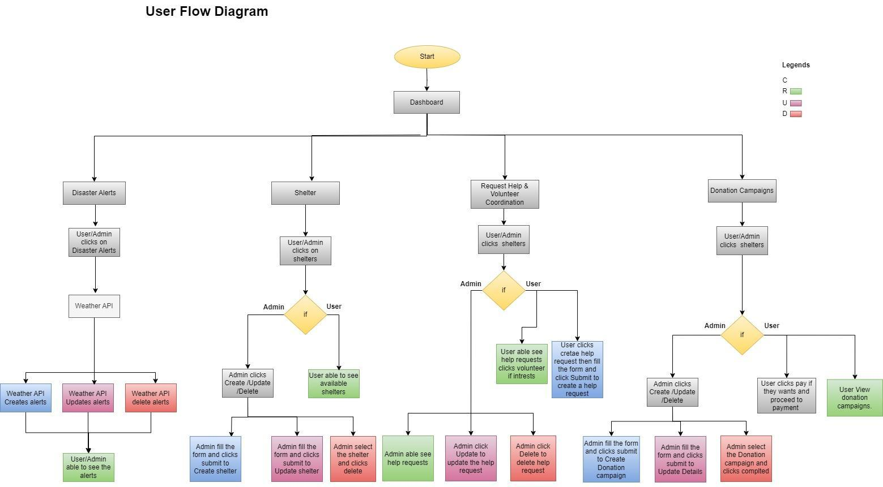

### **3. Subsystem/Component Forms**

#### **Component 1: Disaster Alerts**

* **Description**: This component allows admins to create, update, and delete real-time alerts for disasters. Users can view these alerts based on their location.

|  |  |
| --- | --- |
| Operation | Screenshoot |
| Create |  |
| Read |  |
| Update |  |
| Delete |  |
| Mongodb Cloud atlas after adding the data. |  |

#### **Component 2: Donation Campaigns**

* **Description**: This component enables admins to create and update donation campaigns. Users can view and contribute to donation campaigns.

|  |  |
| --- | --- |
| Operation | Screenshoot |
| Create |  |
| Read |  |
| Update |  |
| Delete |  |
| Mongodb Cloud atlas after adding the data. |  |

#### **Component 3: Help Requests & Volunteers**

* **Description**: This component allows users to request help and for volunteers to sign up. It also enables admins to manage and update requests.

|  |  |
| --- | --- |
| Operation | Screenshoot |
| Create |  |
| Read |  |
| Update |  |
| Delete |  |
| Mongodb Cloud atlas after adding the data. |  |

#### **Component 4: Shelter Locations**

* **Description**: This component enables admins to register shelter locations and resources. Users can view the available shelters and their capacity.
* We also integrated the Google Maps API in this component.

|  |  |
| --- | --- |
| Operation | Screenshoot |
| Create |  |
| Read |  |
| Update |  |
| Delete |  |
| Mongodb cloud atlas after adding the data. |  |

* **Google Maps API:** We also integrated the Google maps api in the shelter component.After selecting the country and city in the shelter component you can able to see the location red mark in the maps.

